Welcome Pack

MORE ACTIVE, MORE OFTEN

Hello, and welcome to the Holland Sports Get Fit Club. Thanks for choosing to join - it’s great to have you with us. |  |  | We are a community club, run by a dedicated set of enthusiastic volunteers. Our mission is to encourage more of our community to be more active, more often, getting fit for free in our local park. We wish to inspire adults to regularly participate in aerobic activity and strength exercise several times every week.  Everyone can join in, everyone is welcome, let’s get moving together! We invite you to get out there and enjoy your park. Either on your own or with your family and groups of friends. If you need advice or a regular incentive then join us in free training sessions for adults.  The club is driven by our local, experienced and qualified coaches, following a suitable range of guidance such as the NHS "Live Well" scheme to support our community. Whether our members wish to focus on their stretching, conditioning and balance; or wish to start their "from couch to 5k" journey, we will help you.  We wish to gain a wide local membership, emphasising that joining the club is free, as are all of our advice and services. Our target members are unfit/inactive adults, including elderly and disabled persons. Active, fit adults may also join us or continue in our club, gaining our advice to continue their healthy lifestyle.  Enjoy!  Barbara Kite  Chairman  Holland Sports Get Fit Club
Our Base  Mill Lane Recreation Ground,  Hurst Green, Surrey RH8 9DG  Facilities:  - New trim trail path, 785 metres long, 2 metres wide  - Three exercise stations: |  | 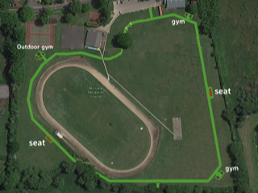
- Ten piece outdoor gym equipment  - New double bar equipment  - New chin ups bar equipment  - MUGA – Multi Use Games Area  - Athletics Track, 400 metres long  - Basketball court  - Three park benches  - Paths to country fields  - Car Park & Skate Park  - Toilets and Changing Room |  | The Mill Lane Recreation Ground, Hurst Green, RH8 9DF is a six hectare public park, one of the King George V “Fields in Trust”. A huge amount of fund raising has been achieved so that our community has a centre for sport, fitness and healthy outdoor activities.  Holland Sports Get Fit Club training sessions will be organised to make use of a range of new and existing facilities. All sessions start and finish at the MUGA, for warm-up and warm-down stretching. The Trim Trail has been designed to combine with the two new exercise stations, park benches and existing Outdoor Gym to offer an all year round circuit.
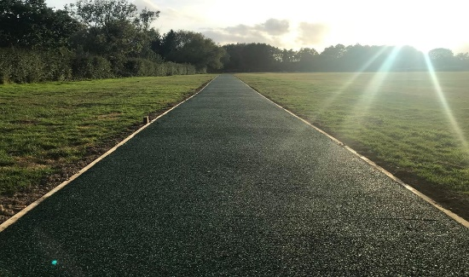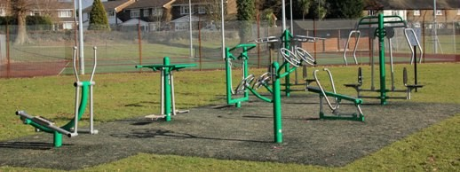

Our Services are FREE
The Holland Sports Get Fit Club wish to encourage our members to find new ways to enjoy the park, to get fit for free and to learn good exercise techniques in groups. It is our aim that members can replicate what they have learnt in an independent way to suit their lifestyle and needs.
Each club training session will be run by two experienced and qualified coaches, local residents in your community who have volunteered their time to help you get more active, more often.
Please Note: All members must complete our “Medical Information and Physical Activity Readiness Questionnaire” and “Contact Form” before participating in a club training session. These documents can be found at https://hollandsportsgetfitclub.teamer.net/teams/111728088-more-active-more-often/documents

Training Sessions:
- Monday 2pm “Over 60’s session” - led by Rachel Nixon and Louise Eadie
- Friday 1:30pm “Get Active session” - led by Sarah Lowe, or Amanda Mullen and Caroline Turk

Our website, social media and a hands on training sessions will aim to share relevant information regarding health issues, fitness programmes and exercise techniques to ensure each member reaches their personal goals. The club will also encourage its members to participate in additional events such as Sports Relief, Children In Need, National Fitness Day and Park Runs.

Stay connected
- For tips, inspiration, training plans and reviews on the latest fitness and wellbeing news keep an eye on our Facebook page and join our group - https://www.facebook.com/HollandSportsGetFitClub
- Sign up for our https://hollandsportsgetfitclub.teamer.net membership, keep up to date with our training sessions and events.
- For any other enquires get in touch via our email - getfit@hollandsportsclub.co.uk

Useful Publications
- NHS – Live Well https://www.nhs.uk/live-well/

- NHS – From Couch to 5k https://www.nhs.uk/live-well/exercise/couch-to-5k-week-by-week/

- Prevention is better than cure
https://assets.publishing.service.gov.uk/government/uploads/system/uploads/attachment_data/file/753688/Prevention_is_better_than_cure_5-11.pdf

Your Get Fit Progress

Date | Where & When | Warm Up | Workout Comments | Warm Down
Date | Where & When | Warm Up | Workout Comments | Warm Down

Get Fit Stretching Guide
Warm Up Exercises
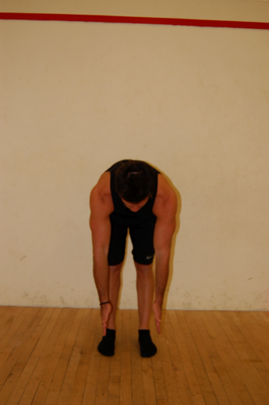 | Flexion (roll downs)  - From above position slowly curl chin to chest and roll down towards floor. Use hands against thighs for support  - when you can’t go any further (don’t go into pain) roll back up  - Repeat up to 8 times  - You can also do this with your back against a wall to help with correct posture | 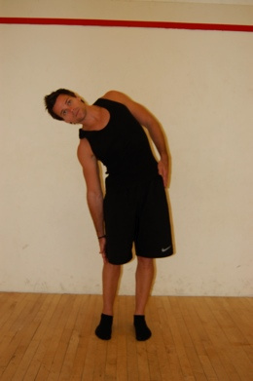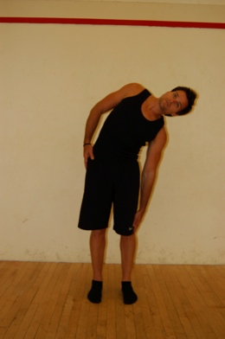 | Side bending  - From standing slowly bend to the right taking your fingers towards the floor.  - Return to upright  - Repeat on the opposite side 4 times each side
 | Squats  - Stand with feet hip width apart, toes facing forwards  - Keep hips level & bend at hips and knees, keeping body upright as possible  - Keep knees behind toes and legs parallel  - Weight should be evenly distributed  - Squeeze bottom and thighs to return to standing  - Repeat 8-12 times | 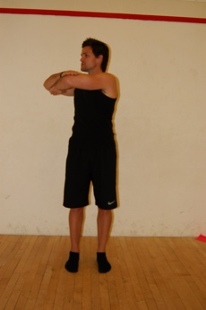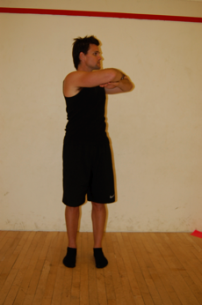 | Rotations  - Cross arms at shoulder height, relax shoulders  - Slowly rotate to the left, back to centre and then to the right  - Try to keep your hips facing forwards but if this hurts your back, let them rotate too.  - Repeat 4-5 times each side
Post Workout Stretches
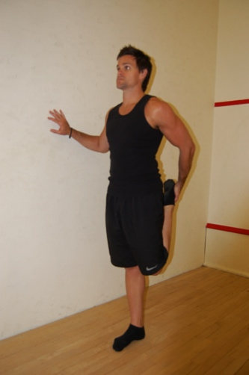 | Quadriceps stretch  - Standing on one leg, hold other foot, bending knee and bringing heel to bottom.  - Keep both knees together  - Hold for 20-30 seconds  - Repeat and change sides |  | 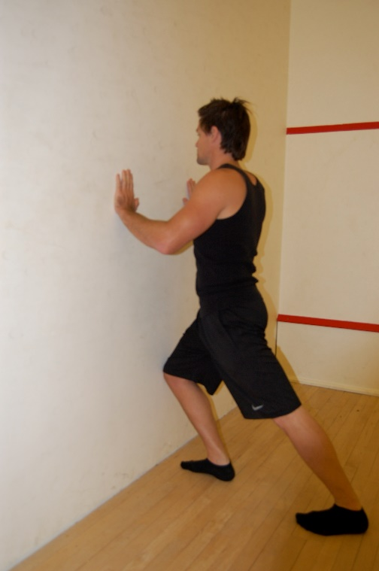 | Calf Stretch  - Stand facing a wall or fence  - Bend front knee and push back heel into the ground  - Hold for 20-30 seconds  - Repeat and change sides
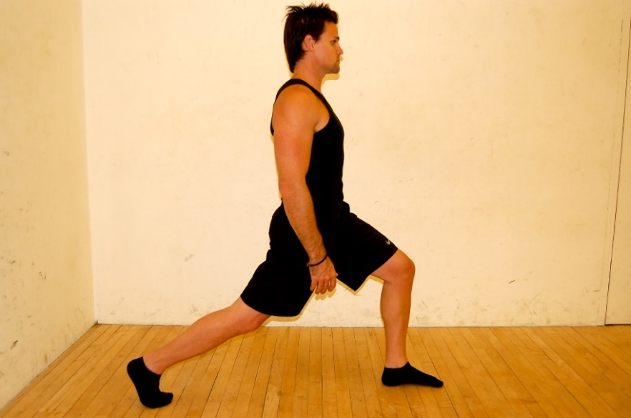 |  | Hip Flexor Stretch  - Take one foot in front of the other and bend your front knee  - Sink down towards the floor keeping your weight central  - Hold for 20-30 seconds  - Repeat and change sides |  | Side Stretch  - Standing with feet hip width apart  - Reach one arm up and overhead whilst bending to one side  - Hold for 20 secs Repeat and change sides

